The Treasurers’ Site

*USER’S MANUAL*

1st Revision

17 APRIL 2017

*By*

*Raphael Jong Jun Jie*

**Contents**

***1*****GETTING STARTED**

***1.1*** Introduction

***1.2*** System’s structure

***1.3*** Important notes when accessing the website

***2*** **USING THE SYSTEM**

***2.1*** Log in

***2.1.1*** User’s id and password explained

***2.1.2*** How to get an account?

***2.2*** Roles and Responsibilities

***2.2.1*** Students

***2.2.2*** Treasurers

***2.2.3*** School authorities

***2.2.4*** Super admin / webmaster

***2.3*** System menu

***2.3.1*** Students’ menu

***2.3.2*** Treasurers’ menu

***2.4*** Functions

***2.4.1*** Students

***2.4.1.1*** Payments

***2.4.1.2*** Profile

***2.4.1.3*** Settings

***2.4.1.3.1*** Change username

***2.4.1.3.2*** Change password

***2.4.1.4*** Log out

***2.4.2*** Treasurers

***2.4.2.1*** Changing view

***2.4.2.2*** Summary

***2.4.2.3*** Students

***2.4.2.3.1*** Name list

***2.4.2.3.2*** Add students

***2.4.2.3.3*** Edit students’ profile

***2.4.2.3.4*** Edit students’ payment status

***2.4.2.3.5*** Delete students

***2.4.2.4*** Payments

***2.4.2.4.1*** Payment list

***2.4.2.4.2*** Add payments

***2.4.2.4.3*** Edit payment information

**Contents**

***2.4.2.4.4*** Delete payments

***2.4.2.5*** Expenses

***2.4.2.5.1*** Expenses list

***2.4.2.5.2*** Add expenses

***2.4.2.5.3*** Edit expenses information

***2.4.2.5.4*** Delete expenses

***2.4.2.6*** Profile

***2.4.2.7*** Settings

***2.4.2.7.1*** Change username

***2.4.2.7.2*** Change password

***2.4.2.8*** Log out

***2.5*** More about the system

***2.5.1*** What do the text colours represent?

***2.5.2*** How is the calculation carried out?

***2.5.3*** Precautions when making changes to data

***2.6*** Other usages

***2.6.1*** Personal money management system

***2.6.2*** Teacher as the treasurer

***3*** REPORTS

***3.1*** Report bugs

***3.1.1*** What to report?

***3.1.2*** How to report?

***3.1.3*** Whom to report?

**3.1.4** What else can be reported?

**4** REFERENCES

**4.1** List of roles and their codes

**4.2** List of classes and their codes

**5** GLOSARY

***1. GETTING STARTED***

This user’s manual is a reference for those who are using the system “The Treasurers’ Site” but are not familiar with the system. This system is a web-based application which is also called a web app. The website for this application is *<http://the-treasurers-site.000webhostapp.com>*

In this user’s manual, you will learn how to use this web app correctly.

**1.1 Introduction**

“The Treasurers’ Site” is a web app/system built specially for school treasurers to help them manage their class fund, expenses etc. in an easy way. With this web app, treasurers will no longer need to keep every record of the things related with their class fund. This web app is currently available for SMJK Kuching High students only. However, this web app is open to all for testing purpose.

This web app is there to help treasurers calculate how much class fund and money is left, keep most of the records in a simple yet organised way. Students will also have their own account to log in to view the details of the payments they will need to make.

Enough talking, let’s get started!

**1.2 System’s Structure**

The system’s structure is simple.

1. For students

* Log in page
* A banner
* A menu
* An area where data are displayed

1. For treasurers

* Log in page
* A banner
* Change view area
* A menu
* An area where data are displayed

**1.3 Important Notes When Accessing the Site**

There are some important things to take note when you are trying to access the site(website):

1. This site is regarded as dangerous by Google Chrome and it stops you

from accessing the website. If you want to use Google

Chrome to access the website, go incognito(Ctrl+Shift+N). Relax, this

site is not any hacking site. You will know what I’m talking about once

you use this web app.

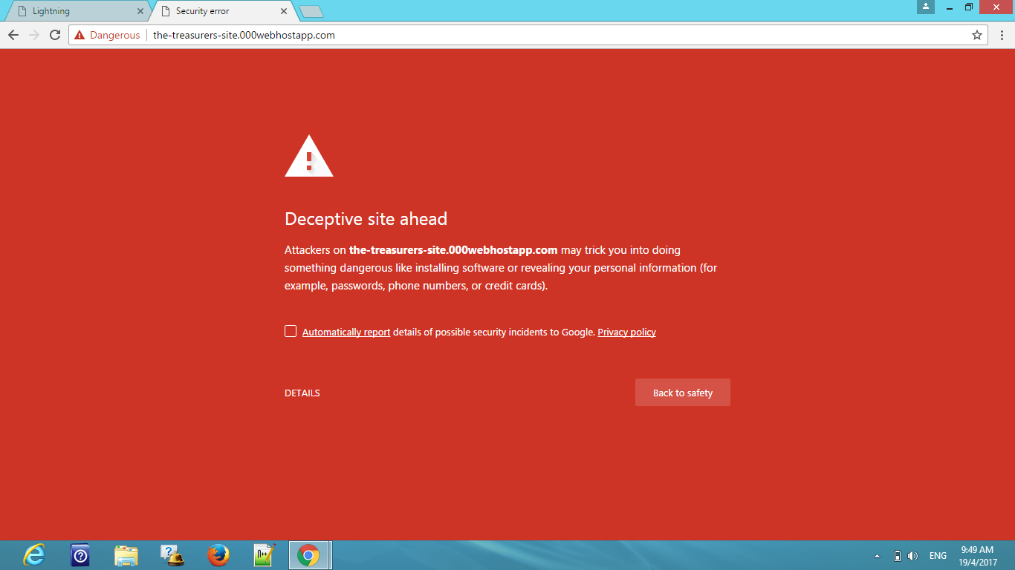

*Picture 1.3 - 1 Site regarded as dangerous by Google Chrome*

1. This web app is suitable for computers but you can still use it using

your smartphone. The only issue with smartphones is that you get

very small text and you’ll need to zoom in and out frequently.

1. Mozilla Firefox is the most suitable web browser for accessing this

web app. You can access the website just like that in Mozilla Firefox.

1. Avoid using Internet Explorer.
2. This site might not be accessible if you are trying to use this web app

in your school i.e. the school library’s computers and the computer

lab. You know what I mean.

***2. USING THE SYSTEM***

In this part, you will learn how to use the system and how it works.

**2.1 Log In**

Since this web app can be used by multiple treasurers and students and maybe even schools in the future, this web app definitely requires a log in. You will need to have a user id and a password to log in. If you are reading this user’s manual or have this user’s manual, you sure will have a user id and a password.

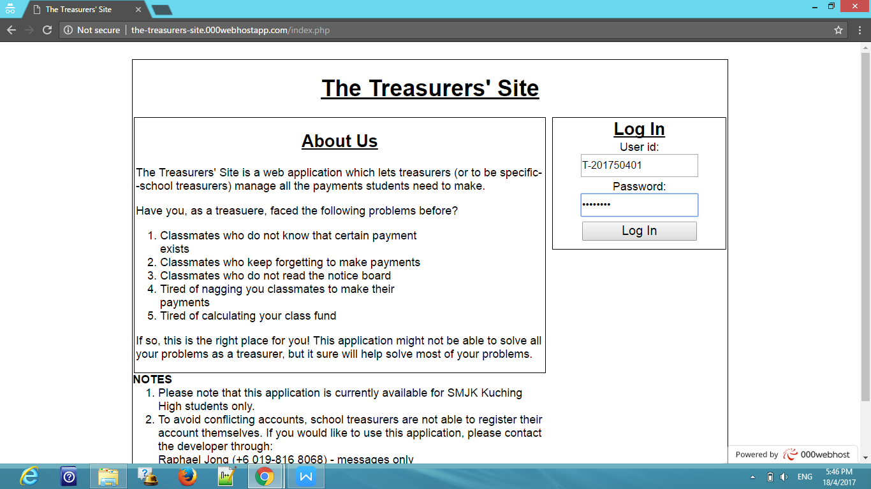

*Picture 2.1-1 Log In Area*

If the log in is successful, you will be brought to your home page where you will see a summarized list. We will go deeper to the summarized list at later part.

However, if your log in is unsuccessful, you will get an error message displayed in red at the bottom of the log in button stating, “Invalid id and/or password”.

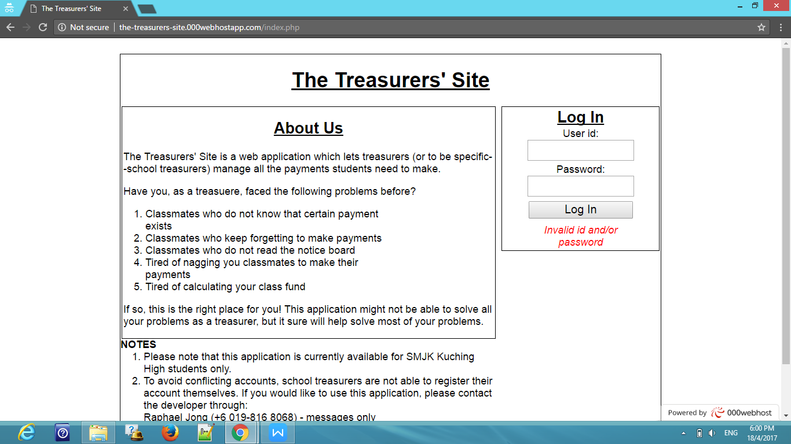

*Picture 2.1-2 Unsuccessful log in*

**2.1.1 User Id and Password Explained**

Did you notice the user id in *Picture 2.1-1 Log In Area? Did you* notice something familiar in the user id? Did you know that there is a simple way to remember your user id? Did you know how the user id is created? Did you know that the user id actually has a “relationship” with the corresponding password at the instance it is created? All this will be explained in this part and it’s very simple.

Now, let’s take a look at the user id. We will use the user id in *Picture 2.1-1 Log In Area* for the explanation.

The user id can be split into 4 parts -- role, current year, class and the nth student’s account created by his/her treasurer. The following shows how the user id is split.

T-201750401

1. The text highlighted in cyan represents the role of the user.
2. The text highlighted in green represents the current year. This means that at the beginning of a new year, all the old data including every account used in the web app will be cleared or in other words-- the website will be “renewed”.
3. The text highlighted in yellow represents the class of the school. The classes are based on the existing classes in SMJK Kuching High.
4. The text highlighted in purple represents the number of the nth student’s account created by his/her treasurer. The number “01” is always reserved for treasurers.

5. The hyphen/dash (“-”) is only used to separate the alphabets and the numbers.

1. Now, let’s take a look at the “relationship” between the user id and its corresponding password at the instance the account is created. For security reasons, all passwords are the same as the user ids by default since your account is created manually, not automatically. This is why you will be asked to changed your password at the instance you receive your user id because your account can be easily hacked by other students or maybe other treasurers if they want to.

*\* The list of roles and classes and their corresponding codes can be found in the references part.*

Example

1. The user id “T-201710101” means that the user is a treasurer of Class

1A in the year 2017 and the account is the 1st account created.

1. The user id “S-201730723” means that the user is a student of Class

3G in the year 2017 and the account is the 23rd account created

including the total number of deleted students in that class.

*\*A student’s user id can only be created* ***IF AND ONLY IF*** *his/her treasurer exists* ***AND*** *the treasurer has an account to use this web app.*

***2.1.2* How to get an account?**

You may wonder, where do I get an account? Well, the only way to get an account by contacting the developer. Below are the contact number of the developer:

Name : Raphael Jong

Phone number: +6 019 816 8068

Facebook : Raphael Jong

E-mail : raphael.jongjj@gmail.com

You can contact the developer through WhatsApp too but not We Chat.

**2.2 Roles and Responsibilities**

In this system, almost every role has its unique responsibilities.

**2.2.1 Students**

Honestly, students do not have any actual responsibilities, they are only responsible to clear all the unsettled payments.

**2.2.2 Treasurers**

In this system, treasurers have the most responsibilities. Treasurers are to :

* Make sure the data keyed in is correct
* Add students, payments and expenses
* Edit wrong student, payments, and expenses information
* Delete unused/unwanted information
* Test the web app
* Report any bugs and/or problems with the web app

**2.2.3 School Authorities**

*\*This role is currently not available*

School authorities are responsible for:

* Adding treasurers into the database
* Migrate students including treasurers if necessary
* Add or delete transferred students
* Test the web app
* Report any bugs and/or problems with the web app

**2.2.4 Super Admin / Webmaster**

*This role is not available for this moment

For now, super admin / webmaster doesn’t have his/her own account, webmaster(s) will have to carry out the followings manually:

* Clear all data at the beginning of a new year
* Create treasurers’ account
* Make sure treasurers’ account information is correct
* Make sure the website is always up
* Fix all bugs and/or problems reported

**2.3 System Menu**

We have gone through the introduction, the log in part and the roles and responsibilities. Now we will go to the functions / features in the system.

All the features are listed in the menu bar, according to your role.